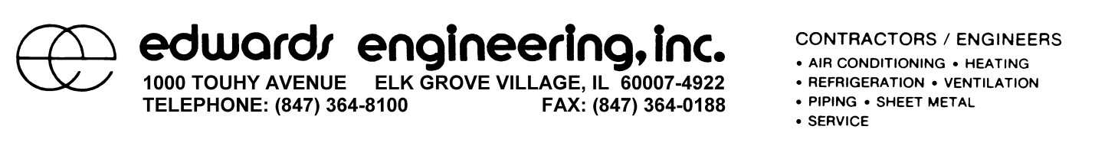
November 7, 2016
To whom it may concern,
It is the policy of Edwards Engineering, Inc., in the effort to maintain a safe working environment, to not hire temporary or short service employees. The work performed by Edwards Engineering, Inc. employees requires extensive training which is gained through a four (4) year apprenticeship. It is our company’s view that hiring any non-union employees, without the essential training and skills for the specialized work we perform, would be a detriment to our company and clients.
What Edwards Engineering, Inc. will do, is hire other specialized trades, such as electricians, carpenters, concrete contractors, etc., to complete work not performed by Edwards Engineering employees. Not categorized as temporary or short service employees, these trades are hired under contract, and referred to as subcontractors by our company.
As a requirement of Edwards Engineering, Inc., in contract with a subcontractor, the subcontractor is required to identify their employees by the subcontractor’s company name. It is the privilege of the subcontractor to identify their employees as they see fit. Company identification may be presented as a logo or name on an item worn by the employee, such as a hard hat, safety vest, t-shirt, etc.
Please accept this letter as an explanation of requirements for the “Short Service Employees (SSE)” portion of RAVS Plus through ISNet World.
Thank you,

Eric J. Hedman CHST, STSC, STS
Safety Manger
Edwards Engineering, Inc.

